**Week 5**

**S.NO:1 Creating Microservices for account and loan**

**SOLUTION CODE**:

**ACCOUNT MICROSERVICE**:

package com.cognizant.account;

import org.springframework.boot.SpringApplication;

import org.springframework.boot.autoconfigure.SpringBootApplication;

@SpringBootApplication

public class AccountApplication {

public static void main(String[] args) {

SpringApplication.*run*(AccountApplication.class, args);

}

}

**ACCOUNT CONTROLLER:**

package com.cognizant.account;

import org.springframework.web.bind.annotation.*;

@RestController

@RequestMapping("/accounts")

public class AccountController {

@GetMapping("/{number}")

public Account getAccountDetails(@PathVariable String number) {

return new Account("00987987973432", "savings", 234343);

}

record Account(String number, String type, double balance) {}

}

**OUTPUT:**

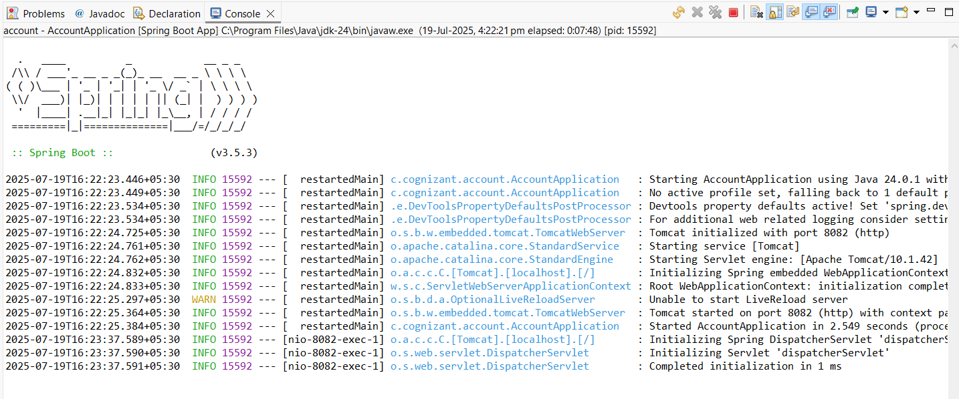

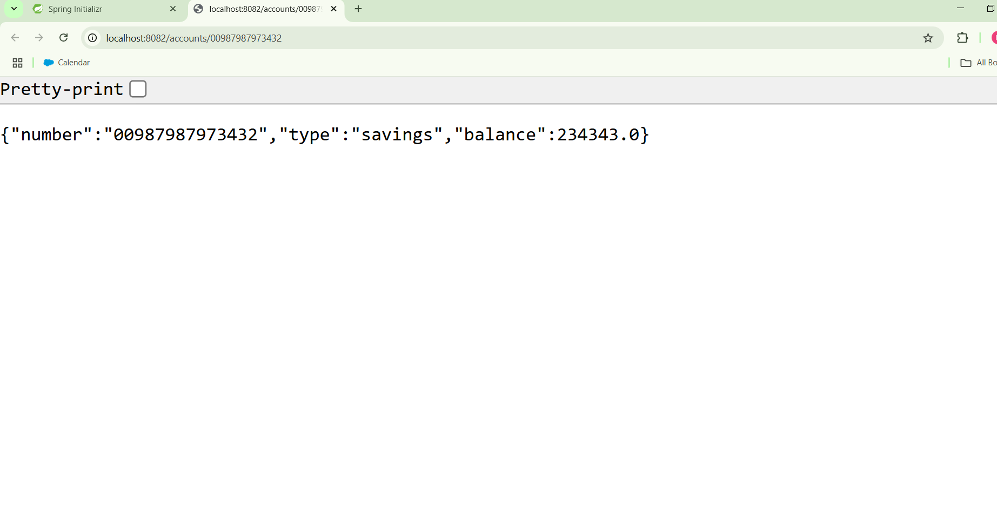

**LOAN MICROSERVICE**:

**SOLUTION CODE:**

package com.cogizant.loan;

import org.springframework.boot.SpringApplication;

import org.springframework.boot.autoconfigure.SpringBootApplication;

@SpringBootApplication

public class LoanApplication {

public static void main(String[] args) {

SpringApplication.*run*(LoanApplication.class, args);

}

}

**LOAN CONTROLLER:**

package com.cognizant.loan;

import org.springframework.web.bind.annotation.*;

@RestController

@RequestMapping("/loans")

public class LoanController {

@GetMapping("/{number}")

public Loan getLoanDetails(@PathVariable String number) {

return new Loan("H00987987972342", "car", 400000, 3258, 18);

}

record Loan(String number, String type, int loan, int emi, int tenure) {}

}

**OUTPUT**:

